
Applecross Senior High School
/25
YEAR 12 PHYSICS

NAME: ______________________________

PRACTICAL ASSESSMENT Part 1
CIRCULAR MOTION

A talented Applecross physics student conducted an experiment investigating circular motion.
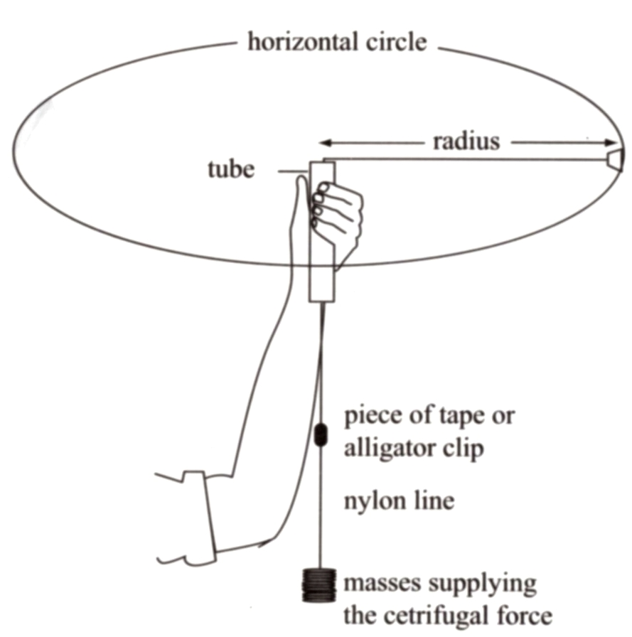

Rubber stopper

Masses supplying the centripetal force (F_{c})

The stopper was whirled in a circle, and the radius of the circle was kept at a constant value
of: 0.600 m

The results obtained were as follows:
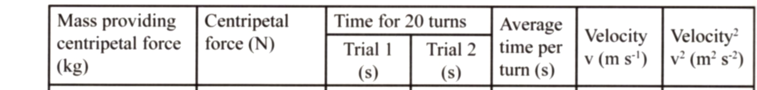

0.200 14.9 15.2

0.250 14.2 13.1

0.300 12.9 11.7

0.400 10.8 10.3

0.450 10.1 10.2

1. Complete the table of results. (2 marks)


2. On the graph paper provided, plot the data of centripetal force versus velocity squared.
(3 marks)

3. Use this graph to determine the mass of the rubber stopper (4 marks)
(Show working here.)

4. If the string sags as shown:
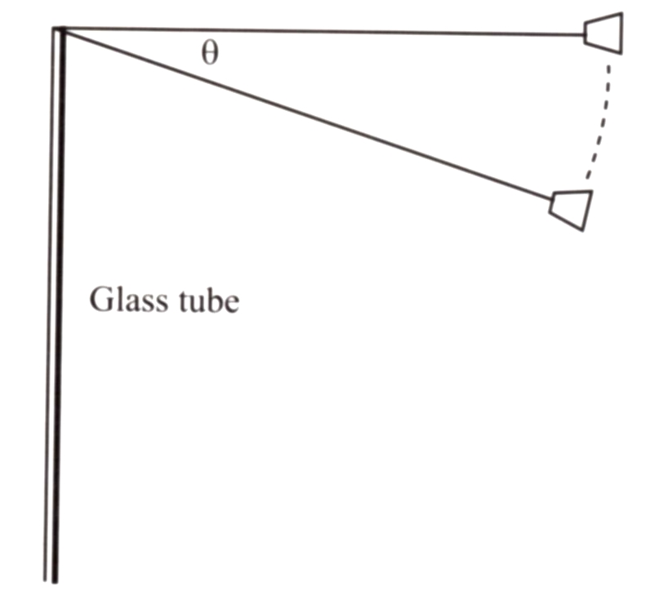
Determine the expression for the component of the force which provides the centripetal acceleration.

Copper tube

TOTAL for Part 1: 10 MARKS

